Answer all the questions.

1. Predict the output for the following code segment:

|  |  |  |  |
| --- | --- | --- | --- |
| (a) | float pasum=1.11; printf("%.2f\n",pasum);  printf("%.2f\n",pasum++);  printf("%.2f\n",pasum);  printf("%.2f\n",pasum--);  printf("%.2f\n",pasum); | (b) | float um=1.11; printf("%.2f\n",um);  printf("%.2f\n",++um);  printf("%.2f\n",um);  printf("%.2f\n",--um);  printf("%.2f\n",um); |
| (c) | char a = 'S';  double b = 4.65;  printf("Size of variable a : %d\n",sizeof(a));  printf("Size of variable b : %d\n",sizeof(b)); | | |
| (d) | int x=4, y=8;  printf("4&8 = %d\n",x&y);  printf("4|8 = %d\n",x|y);  printf("4^8 = %d\n",x^y);  printf("4<<1 = %d\n",x<<1);  printf("8<<1 = %d\n",y<<1);  printf("8<<2 = %d\n",y<<2); | | |

1. Predict the output of the following code segment:

|  |  |  |  |
| --- | --- | --- | --- |
| (a) | float x=25.0,y=10.0; if(y!=(x-10.0))  x=x-10.0;  else  x=x/2.0; printf("%.2f",x);  // 15.00 | (b) | int i = 20;  if (i == 10)  printf("i is 10");  else if (i == 15)  printf("i is 15");  else if (i == 20)  printf("i is 20");  else  printf("i is not present"); |

(c) int a=3, b=7;

if (a>=b)

a=b%a;

else

a=7/3;

printf("%d",a);

1. Predict the output of C code below:

#include <stdio.h>

int main()

{

int a = 5, b = 5, c = 10;

printf("%d == %d is %d \n", a, b, a == b);

printf("%d == %d is %d \n", a, c, a == c);

printf("%d > %d is %d \n", a, b, a > b);

printf("%d > %d is %d \n", a, c, a > c);

printf("%d < %d is %d \n", a, b, a < b);

printf("%d < %d is %d \n", a, c, a < c);

printf("%d != %d is %d \n", a, b, a != b);

printf("%d != %d is %d \n", a, c, a != c);

printf("%d >= %d is %d \n", a, b, a >= b);

printf("%d >= %d is %d \n", a, c, a >= c);

printf("%d <= %d is %d \n", a, b, a <= b);

printf("%d <= %d is %d \n", a, c, a <= c);

return 0;

}

1. Write a C program that reads an integer and determines and prints whether it is odd or even by using the selection structure if..else.
2. Write a C program that reads a letter of an alphabet and determines and prints whether it is vowel or consonant.
3. Write a C program that will read THREE integer numbers and display all the digits in ascending order. Then, calculates and prints the sum of all the digits.

(hints: use if…else Ladder with rational and bit wise operator)

1. Write C program for the flowchart below:

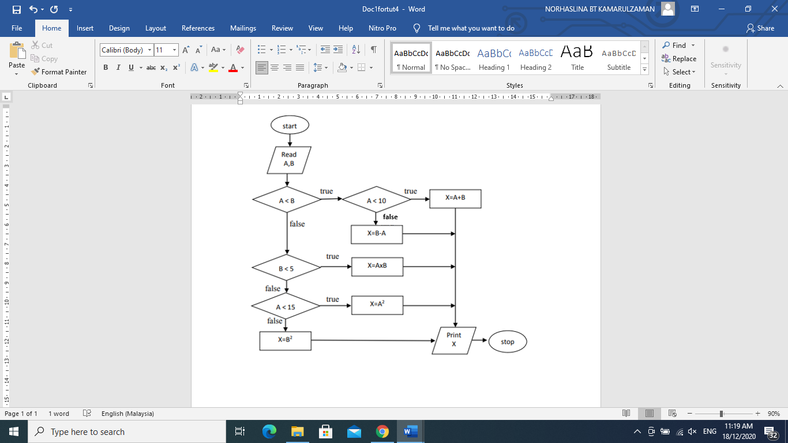

1. Find the errors from the following program

Line 1:#include <stdio.h>

Line 2:

Line 3:int main()

Line 4:{

Line 5:float cough, flu, fever;

Line 6:printf("Please answer the question correctly\n");

Line 7:printf("Do you have a cough? (Type 0 for No, 1 for Yes)");

Line 8:scanf("%d",&cough);

Line 9:printf("Do you have a flu? (Type 0 for No, 1 for Yes)");

Line 10:scanf("%d",&flu);

Line 11:printf("Do you have a fever? (Type 0 for No, 1 for Yes)");

Line 12:scanf("%d",&fever);

Line 13:

Line 14:if(cough==1&flu==1&fever==1)

Line 15:printf("Please see the doctor immediately");

Line 16:else (cough==1&&flu==1&&fever==0)

Line 17:printf("Please take cough and flu medicines");

Line 18:else

Line 19:printf("Please drink a lot of water and take some rest");

Line 20:return 0;

Line 21:}

#include <stdio.h>

int main()

{

float cough, flu, fever;

printf("Please answer the question correctly\n");

printf("Do you have a cough? (Type 0 for No, 1 for Yes)");

scanf("%f",&cough);

printf("Do you have a flu? (Type 0 for No, 1 for Yes)");

scanf("%f",&flu);

printf("Do you have a fever? (Type 0 for No, 1 for Yes)");

scanf("%f",&fever);

if(cough==1&&flu==1&&fever==1)

printf("Please see the doctor immediately");

else if(cough==1&&flu==1&&fever==0)

printf("Please take cough and flu medicines");

else

printf("Please drink a lot of water and take some rest");

return 0;